

Global climate change affects everyone on the Earth. The Intergovernmental Panel on Climate Change (IPCC) warns that our window of opportunity to cut our greenhouse gas emissions to a level low enough to stop the global warming trend over the next 100 years is about to close.

Although many people worldwide have been working to reduce greenhouse gas emissions, they are still on the rise. With all the good information we’ve had for years now, we are still not doing what needs to be done to reduce these greenhouse gas emissions – carbon dioxide, nitrous oxide, methane and others – nearly enough to stop the devastating effects on the Earth in the coming years – more frequent and severe storms, floods, droughts, forest fires, the spread of diseases and destructive insects.

These sound like the pestilences described in the Bible. Still, we are not yet acting to prevent them.

Why?

This show takes audiences, in a compassionate way, on a journey around the world and into ourselves and our society to find out. It provides both catharsis and inspiration to help us reach the needed emissions targets in the next few years.



We will minimize our carbon footprint when presenting the show, using as little fuel as possible while traveling, and we will offset our emissions.

In addition to live performances, we will post the show on the internet so it can be seen by people across the U.S. and beyond. We will encourage an online forum for feedback and to facilitate the sharing of ideas and information beyond the viewing of the show.

Contact us at:

Irthlingz
POB 969, Eastsound, WA 98245
Phone: (360) 376-5773
Email: sharmuse@gmail.com
Web: www.irthlingz.org

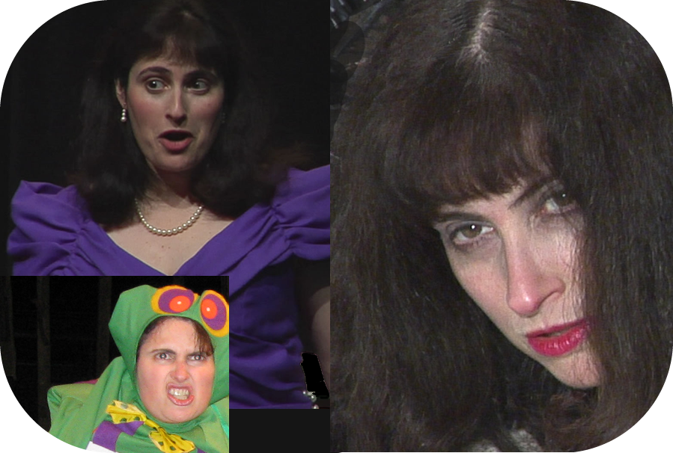



A one-woman musical show
about global climate change

“The Climate Monologues” brings to life onstage the stories of real people in the U.S. and around the world affected by climate change and people working to solve the climate crisis. Their stories are communicated through their own words and through original songs that complement the stories.

“The Climate Monologues” is about:

- People, Passion, Ideas
- Vision & Values
- Facing our fears and rising above them
- Inspiration, courage and keeping our humanity and sense of humor in the face of critical challenges

Irthlingz Arts-Based Environmental Education

Since its founding in 2002, Irthlingz has pursued its mission to engage, educate and inspire people to become stewards of the Earth. Projects have included environmental musical shows such as the Penguins on Thin Ice climate change musical revue, which was performed by students from New York’s High School for Environmental Studies at the United Nations for the U.N. Commission on Sustainable Development in 2007, for which the students received a standing ovation. We have brought our music to the World Summit on Sustainable Development in South Africa and U.N. World Environment Day.
There are links to the songs from Penguins on Thin Ice at www.PenguinsOnThinIce.com. The songs in The Climate Monologues will be different from these songs, but these provide a sample of our work.
Testimonials are available at:
www.irthlingz.org/irthlingz/irthlingz_testimonials.html

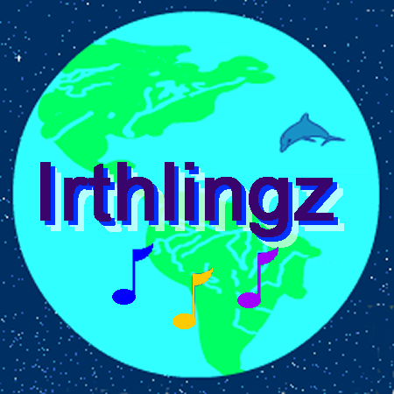
Contact:

Irthlingz
POB 969, Eastsound, WA 98245, USA
Phone: (360) 376-5773
Email: sharmuse@gmail.com
Web: www.irthlingz.org

“The Climate Monologues”

Performances will begin in New York and Washington State beginning in the spring of 2010.

The show is not political. It doesn’t promote any piece of legislation, political candidate or party, and won't jeopardize any organization's not-for-profit status.
Global climate change is a social, health, environmental, economic, and ethical issue that concerns all people. The purpose of the show is to bring people in the U.S. and around the world closer together and inspire people to take action on climate change in their own lives.

By presenting stories of real people and highlighting the human element in dealing with the very real challenge of climate change, it becomes clear how much we are connected to each other and to this challenge. It will be a serious show, but also uplifting and inspiring, with a healthy dose of humor.
The show will run 60-70 minutes. After the show, there will be an opportunity for feedback and discussion about the show and the issue of climate change.
Single engagement performances or a series of performances can be scheduled.
Technical requirements will be minimal. There may be some projections involved if there is access to a projector, and audio will be needed for the pre-recorded musical accompaniment.

Sharon Abreu

Sharon Abreu is executive director of Irthlingz Arts-Based Environmental Education, a tax-exempt nonprofit based in Washington State.

Sharon began combining music and environ-mental education in 1993 after joining New York’s Hudson River Sloop Clearwater while studying voice in New York City. She educated herself about climate change, attending a symposium at the American Museum of Natural History and training to be a speaker with the Green House Network of Portland, OR. Sharon has been singing and speaking about climate change for schools, businesses and community groups since 1999. She is on the roster of the EcoSpeakers speakers’ bureau.

Sharon has served as a delegate to the U.N. Commission on Sustainable Development since she was hired to sing at the U.N. in 1998. Her song Change in the Climate has been featured on Air America’s EcoTalk and WBAI’s EcoLogic. She performed the song at a special planning meeting for the New York Metro Region Input to the New York State Greenhouse Gas Action Plan. She has sung for U.N. World Environment Day and for 2004 Nobel Peace Prize winner Wangari Maathai.

Sharon's bio:

www.irthlingz.org/irthlingz/sharon_abreu_bio.htm

Sharon in performance:

www.ecospeakers.com/speakers/abreus.html - Speaker-Performer, EcoSpeakers speakers’ bureau

www.YouTube.com/ourlittleisland - The Cheap Energy Store (“shop ghoul”) (in 2 parts)

www.sharonabreu.com – classical voice excerpts

